LAB Logbook

Lab 1:

Code:

import numpy as np

sid_last_two = 75

if sid_last_two < 10:

num_elements = sid_last_two + 100

else:

num_elements = sid_last_two

a = np.arange(num_elements)

print("Original array:", a)

a_2d = a.reshape(1, -1)

print("2D array:", a_2d)

saved_array = a_2d

print("Saved array:", saved_array)

print("Shape of the array:", saved_array.shape)

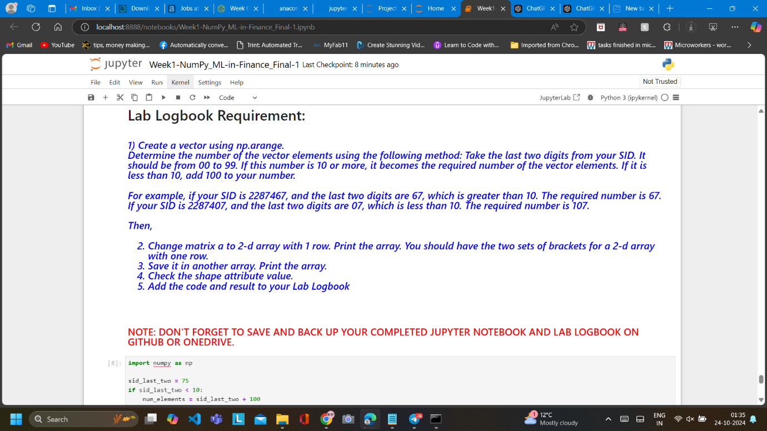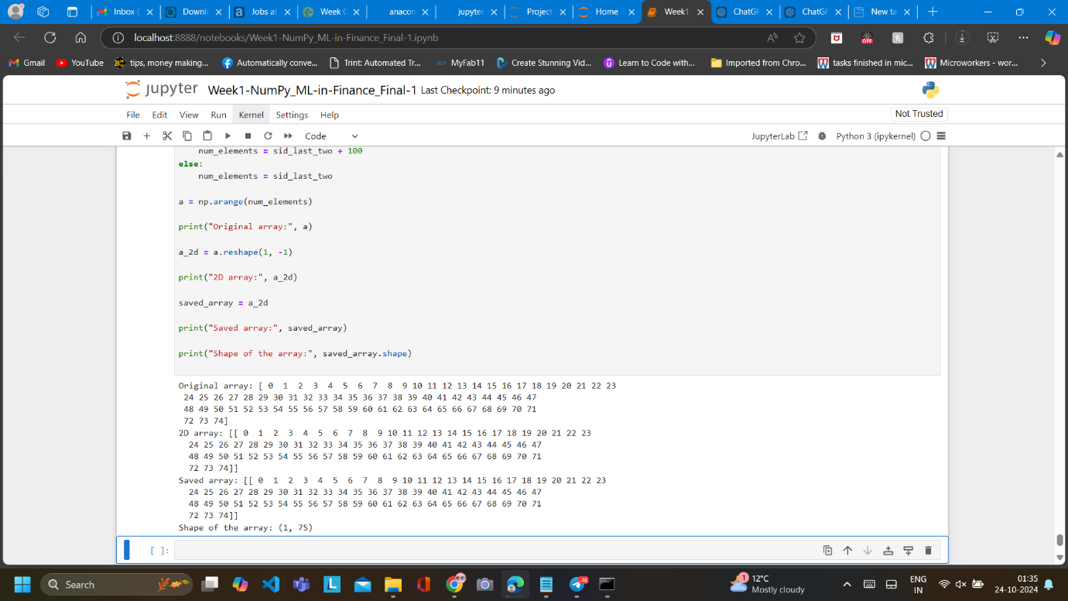

Lab 2

Code :

import pandas as pd

df = pd.read_csv('adult_data_mini.csv')

print("Original DataFrame:")

#print(df)

#n as the last digit of my SID 2331175

n = 5

df['reduced_hours'] = df['hours-per-week'] - n

grouped_df = df.groupby(['relationship', 'reduced_hours']).size().reset_index(name='count')

print("\nGrouped DataFrame:")

print(grouped_df)

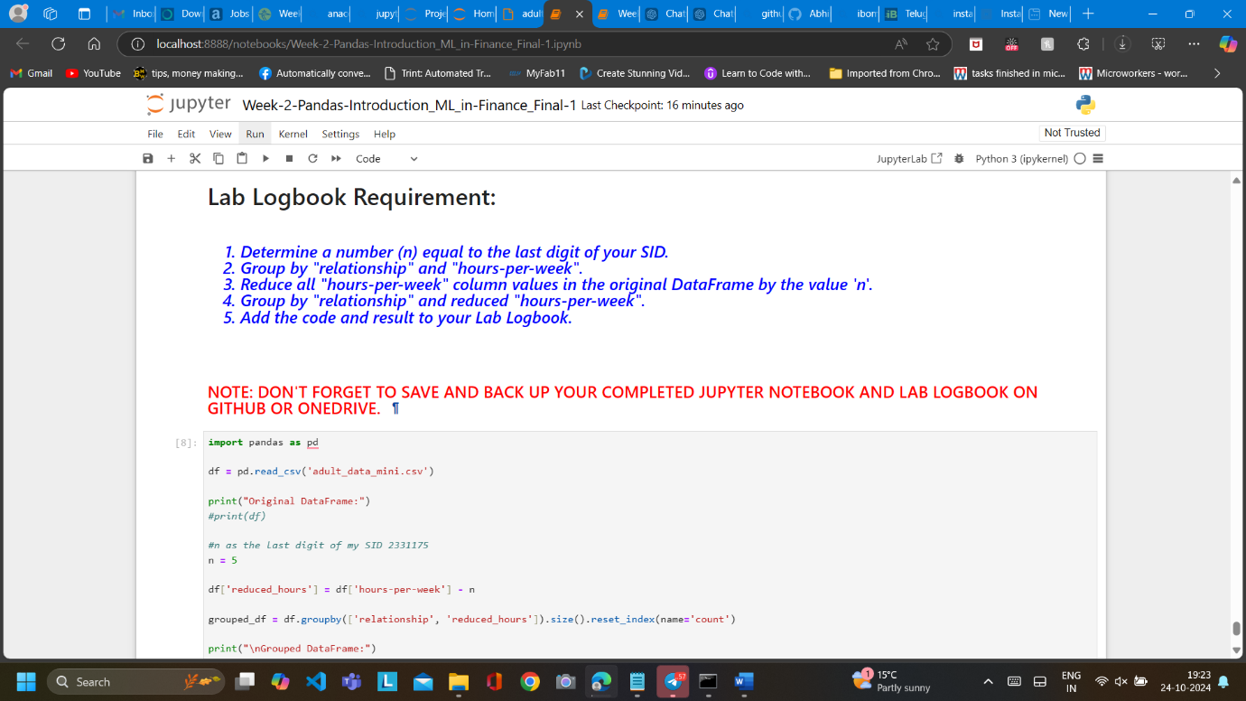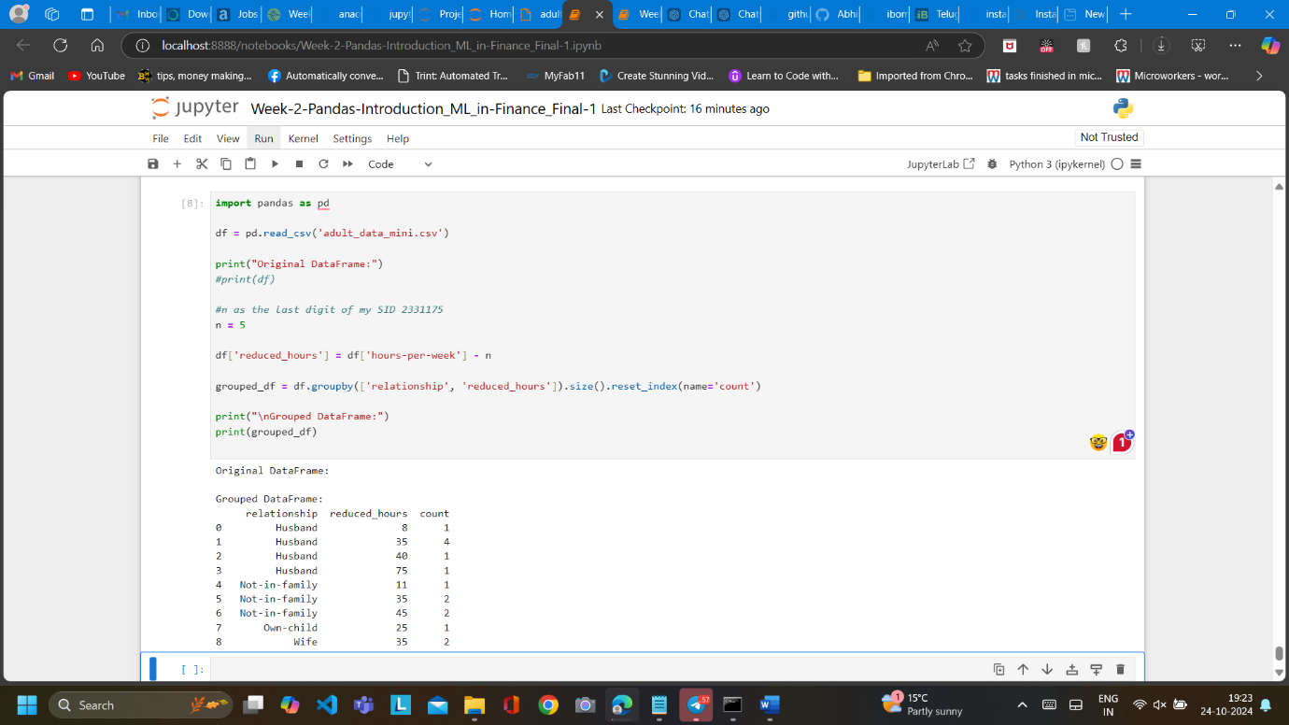

Lab 3

Code:

import pandas as pd

import seaborn as sns

import matplotlib.pyplot as plt

data = pd.read_csv('telecom_churn.csv')

df = pd.DataFrame(data)

# SID:2331175 and selecting 5 (Number vmail messages) and 7 (Total day calls)

columns_to_plot = df[['Number vmail messages', 'Total day calls']]

plt.figure(figsize=(8, 6))

sns.scatterplot(x='Number vmail messages', y='Total day calls', data=columns_to_plot, palette='coolwarm', hue='Total day calls', size='Number vmail messages', sizes=(20, 200), edgecolor="black")

plt.title('Bicolour Interaction: Number of Vmail Messages vs Total Day Calls', fontsize=14)

plt.xlabel('Number of Vmail Messages', fontsize=12)

plt.ylabel('Total Day Calls', fontsize=12)

# Display the plot

plt.show()

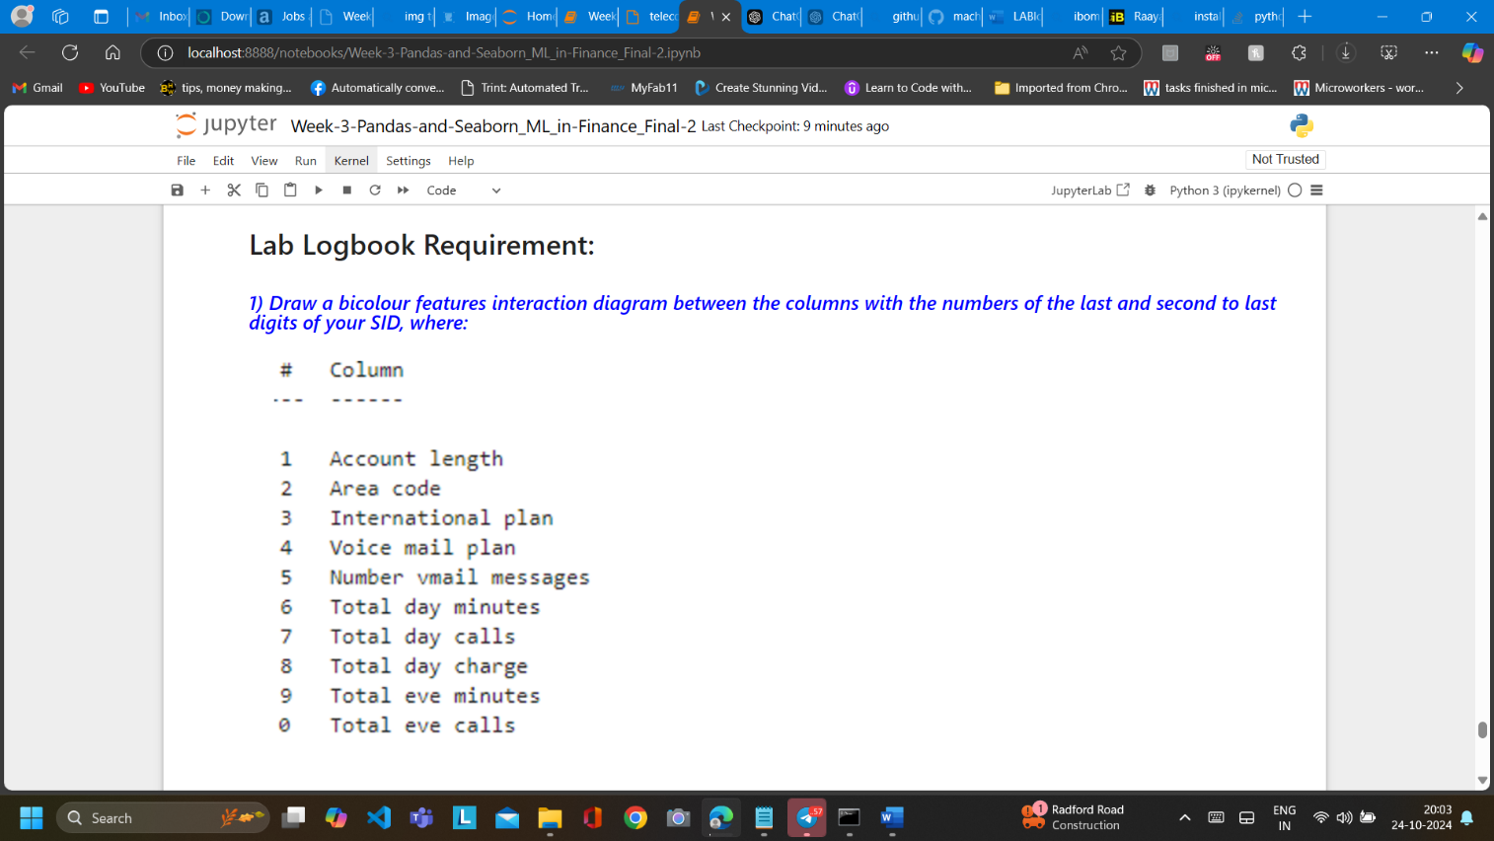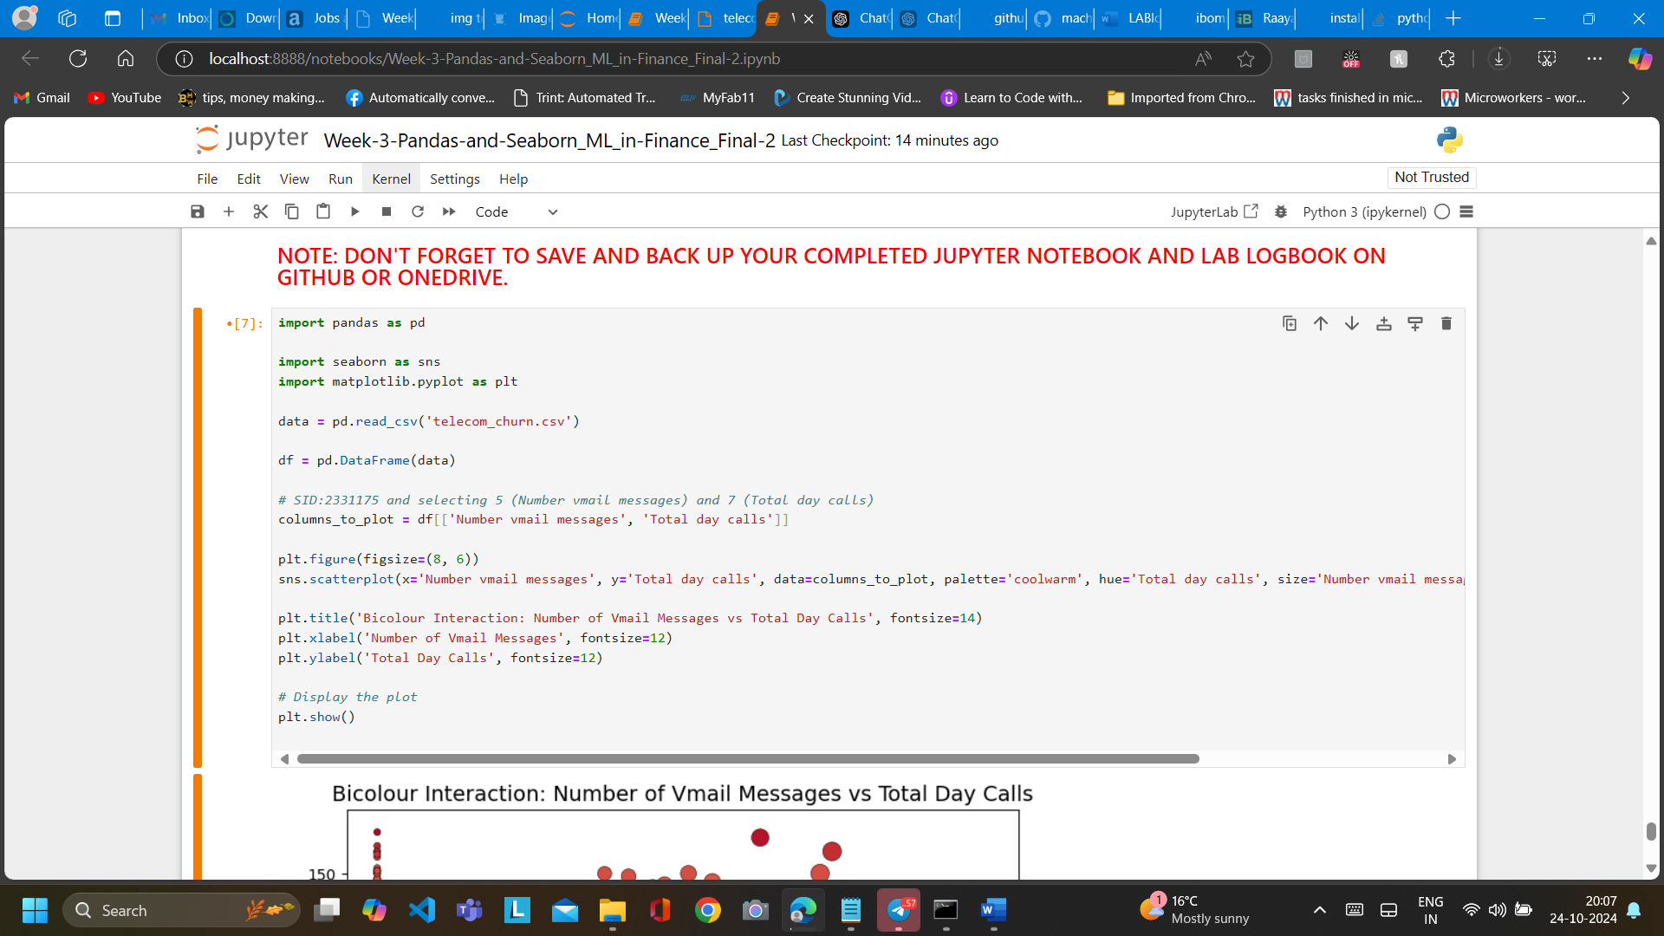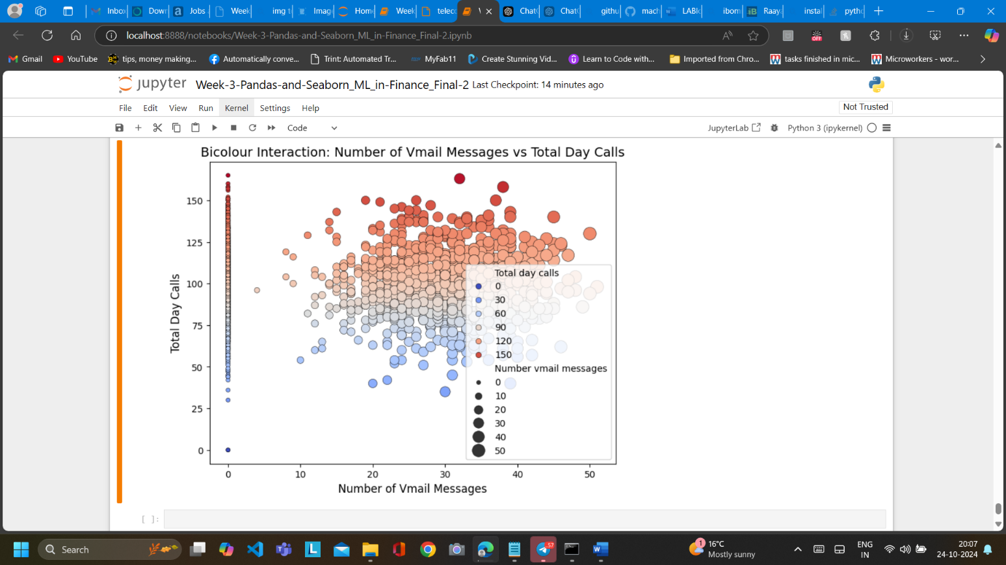

Lab 4

Code:

import pandas as pd

import tensorflow as tf

from tensorflow.keras.models import Sequential

from tensorflow.keras.layers import Dense, Input

from sklearn.model_selection import train_test_split

from sklearn.preprocessing import MinMaxScaler

from sklearn.metrics import mean_absolute_error

data = pd.read_csv('data_stocks.csv')

X = data.drop(columns=['SP500'])

y = data['SP500']

scaler = MinMaxScaler()

X_scaled = scaler.fit_transform(X)

X_train, X_test, y_train, y_test = train_test_split(X_scaled, y, test_size=0.2, random_state=42)

model = Sequential([

Input(shape=(X_train.shape[1],)),

Dense(175, activation='relu'),

Dense(88, activation='relu'),

Dense(1)

])

model.compile(optimizer='adam', loss='mse', metrics=['mae'])

history = model.fit(X_train, y_train, epochs=10, batch_size=32, validation_split=0.2, verbose=1)

test_loss, test_mae = model.evaluate(X_test, y_test, verbose=0)

model.summary()

print(f"\nTest Mean Absolute Error (MAE): {test_mae}")

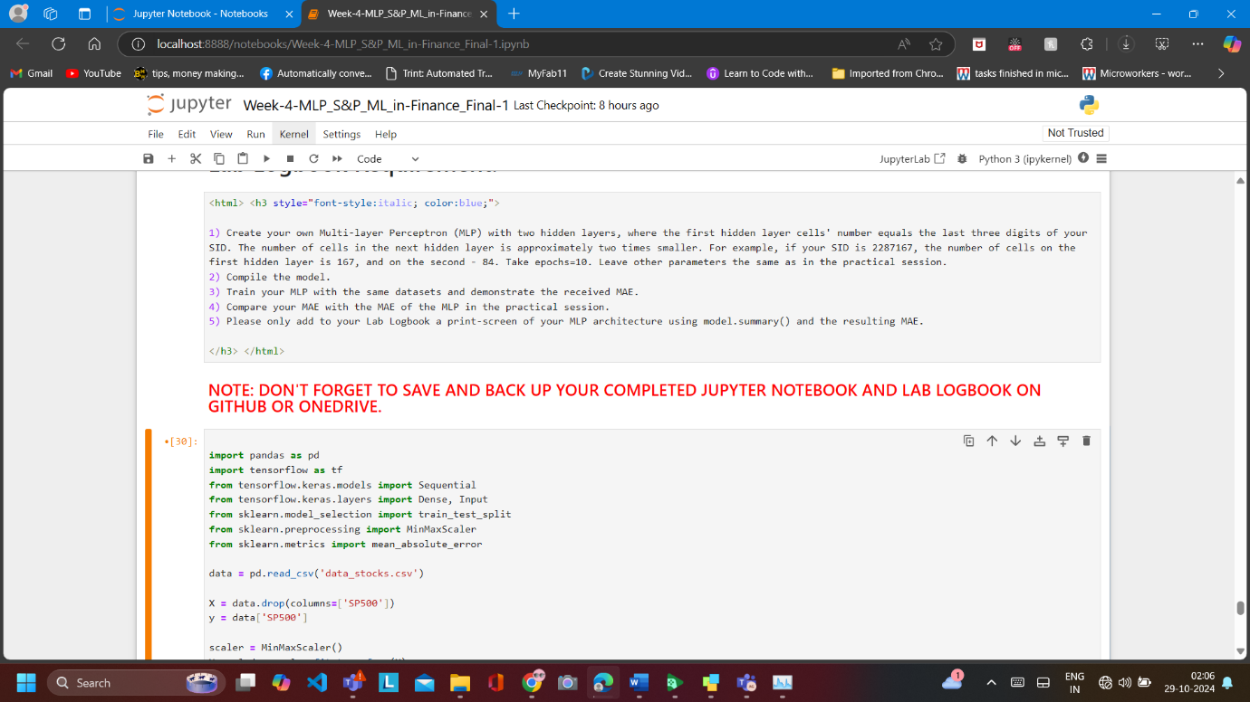

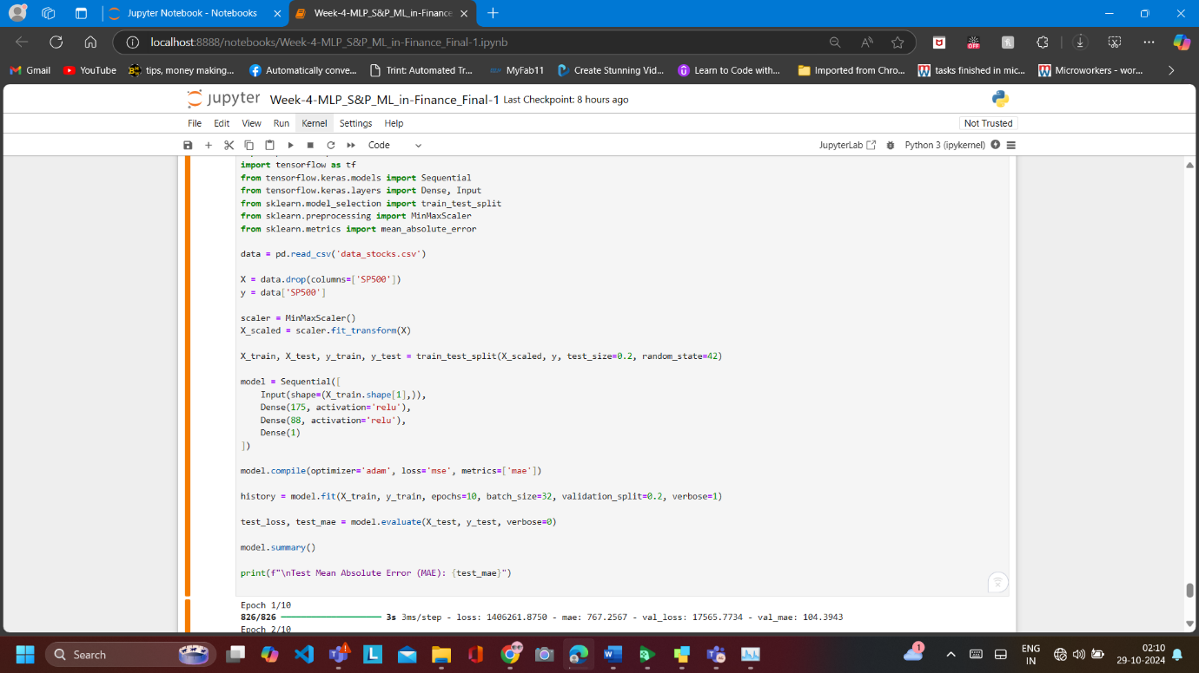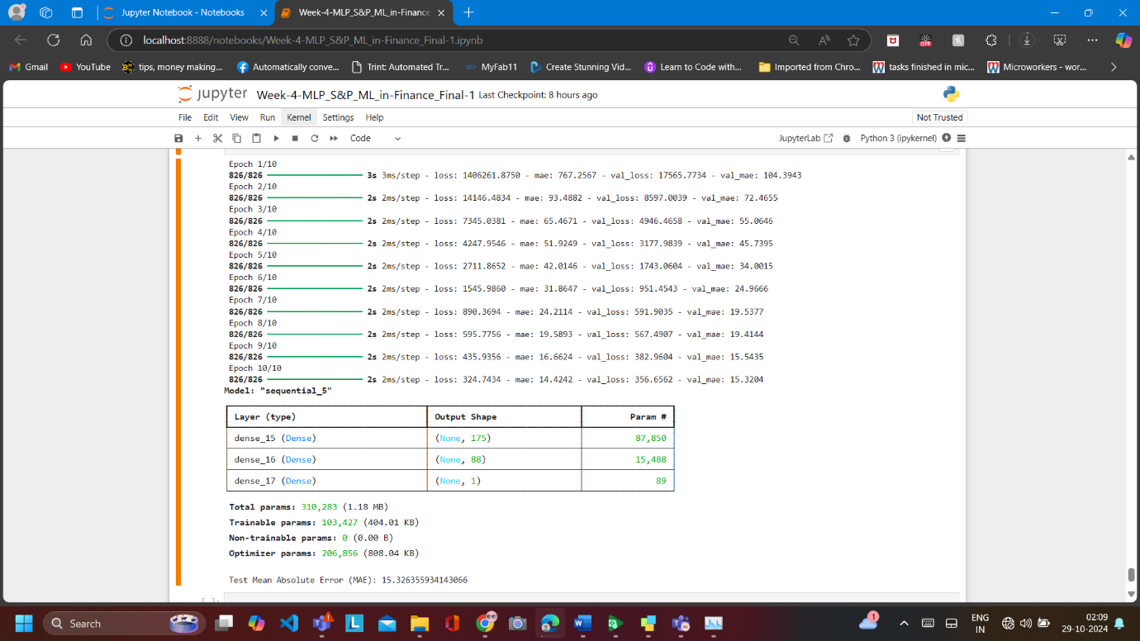

Lab 5

Code:

import pandas as pd

import tensorflow as tf

from tensorflow import keras

from sklearn.model_selection import train_test_split

data = pd.read_csv('EURUSD_tick_OK-2.csv')

X = data[['Vol_Ask_N', 'Ask_N_200_3', 'DateDelta1_N', 'Bid_N_200_3', 'Vol_Bid_N']].values

y = data[['Ask_N_200_3', 'Bid_N_200_3']].values

X = X.reshape(-1, 1, 5)

X_train, X_test, y_train, y_test = train_test_split(X, y, test_size=0.2, random_state=42)

# Calculate number of epochs. sid=2331175

Z = 7

Y = 5

epochs = Z + Y

model = keras.Sequential([

keras.layers.Input(shape=(1, 5)),

keras.layers.Conv1D(50, 5, padding='same', activation='relu', kernel_initializer="normal"),

keras.layers.MaxPooling1D(1),

keras.layers.Conv1D(100, 5, padding='same', activation='relu', kernel_initializer="normal"),

keras.layers.GlobalMaxPooling1D(),

keras.layers.Dense(25, activation='relu', kernel_initializer="normal"),

keras.layers.Dense(2)

])

model.compile(optimizer='adam', loss='mae', metrics=["mae"])

history = model.fit(X_train, y_train, batch_size=50, epochs=epochs, validation_split=0.2, verbose=1)

test_mae = model.evaluate(X_test, y_test)

print(f'Test MAE: {test_mae}')

print(model.summary())

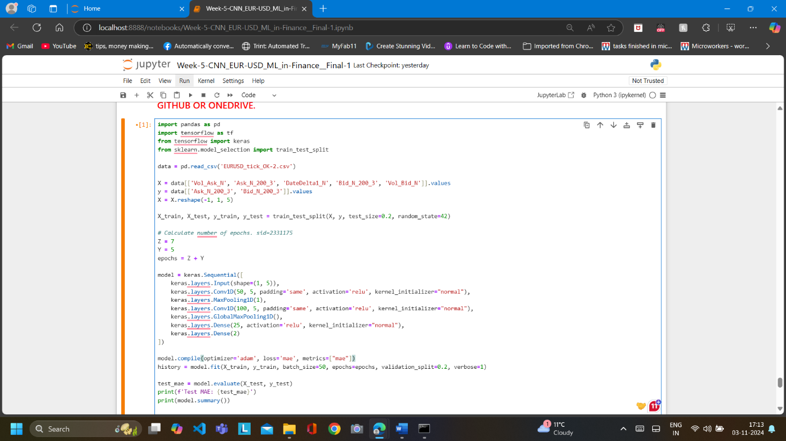

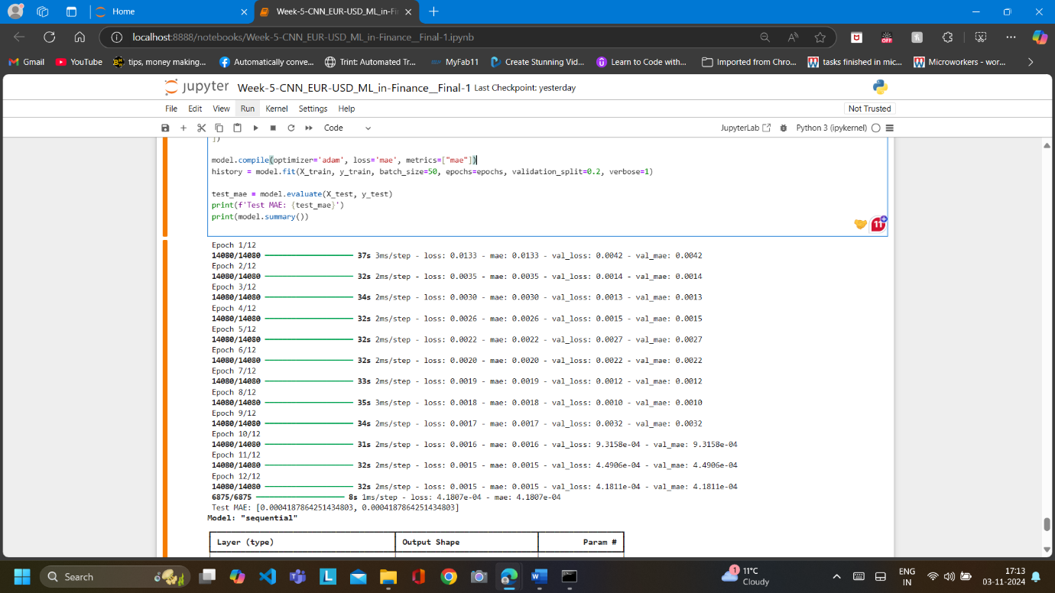

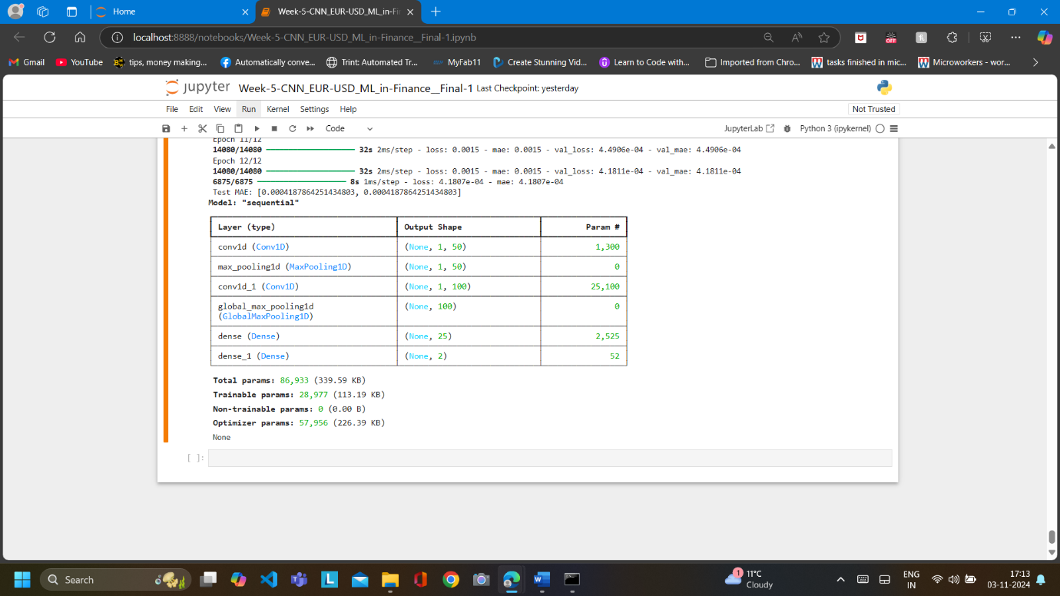

Lab 6

By using cufflinks, I am unable to retrieve the result. Error related to colors even though I didn’t wrote code for colors, it might be an default system error, so I have used below approach to get the same result

Code:

import pandas as pd

from plotly.offline import init_notebook_mode, iplot

import plotly.graph_objs as go

init_notebook_mode(connected=True)

file_path = 'XAUUSD_1 Min_Bid_2022.01.01_2022.12.31.csv'

df = pd.read_csv(file_path)

df.rename(columns={'High': 'High_bid', 'Low': 'Low_bid'}, inplace=True)

df['Time (UTC)'] = pd.to_datetime(df['Time (UTC)'])

start_index = 31175

time_period = 175

subset_df = df.iloc[start_index:start_index + time_period]

trace_high = go.Scatter(x=subset_df['Time (UTC)'], y=subset_df['High_bid'], mode='lines', name='High Bid')

trace_low = go.Scatter(x=subset_df['Time (UTC)'], y=subset_df['Low_bid'], mode='lines', name='Low Bid')

layout = go.Layout(

title="Price Chart of High Bid and Low Bid",

xaxis=dict(title="Time (UTC)"),

yaxis=dict(title="Price")

)

fig = go.Figure(data=[trace_high, trace_low], layout=layout)

iplot(fig)

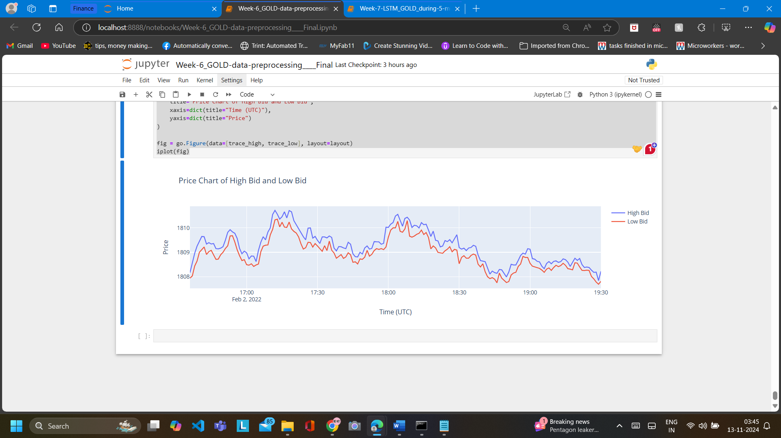

Lab 7

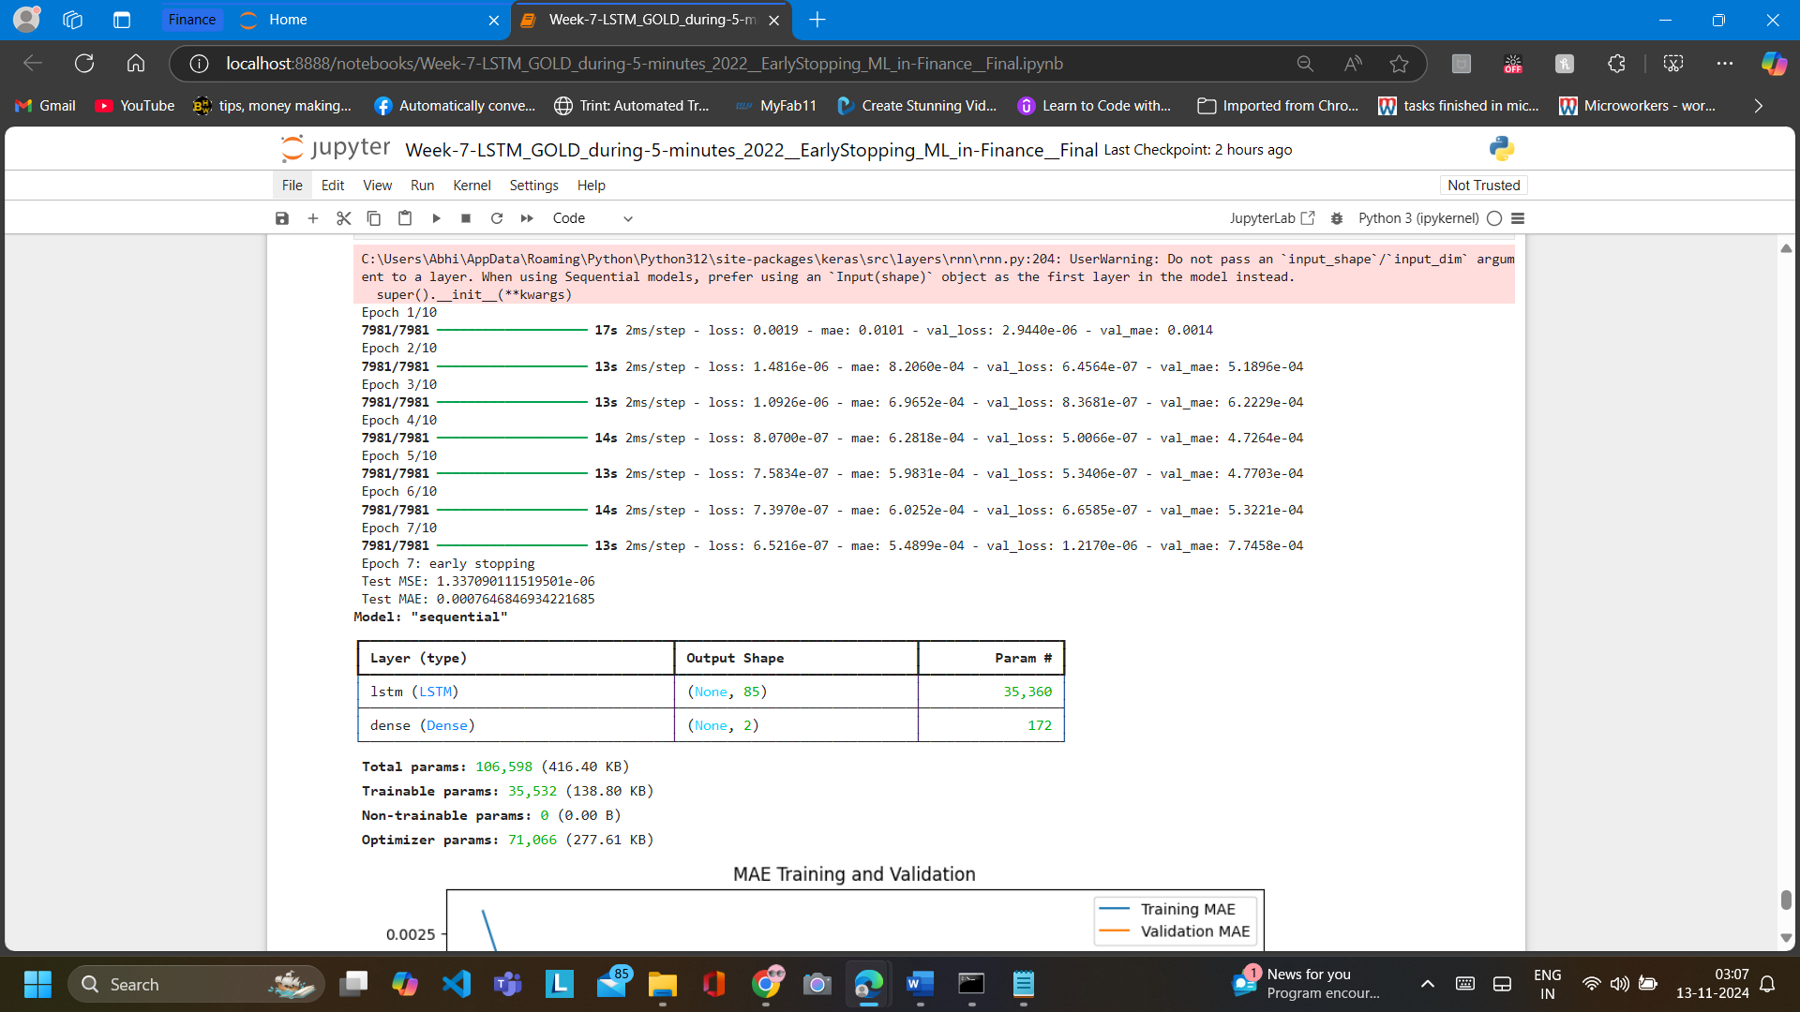

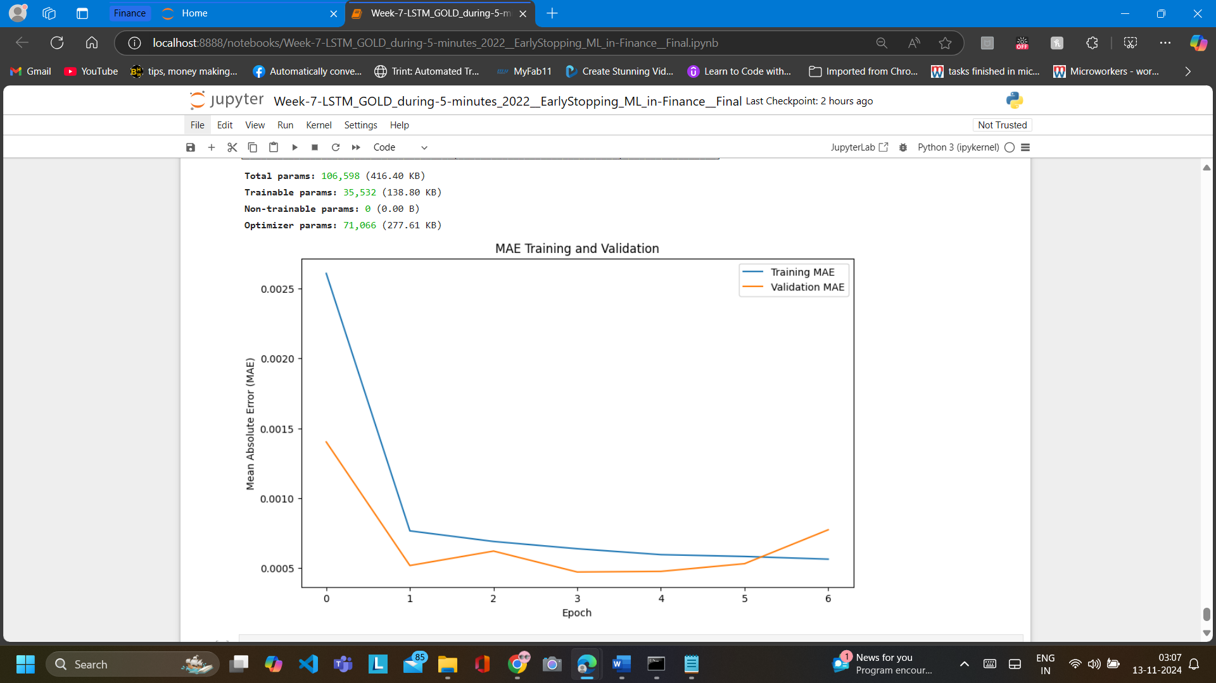

Lab 8

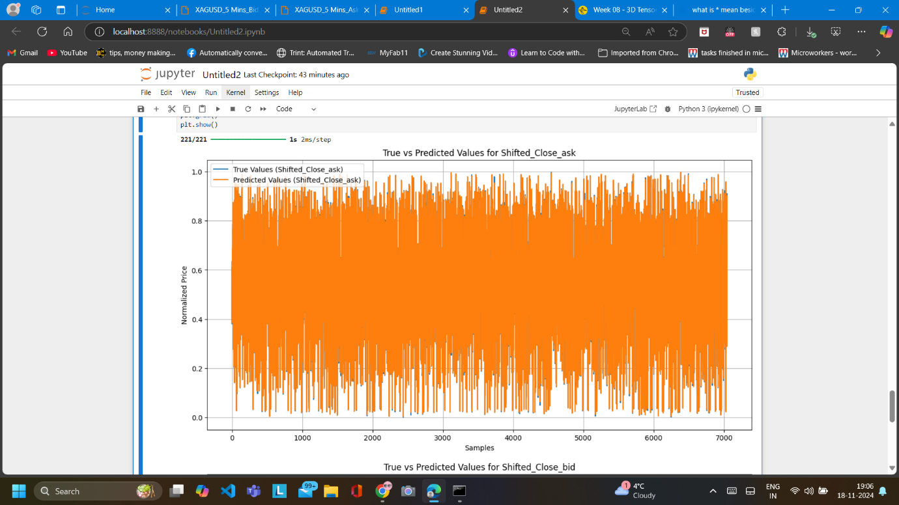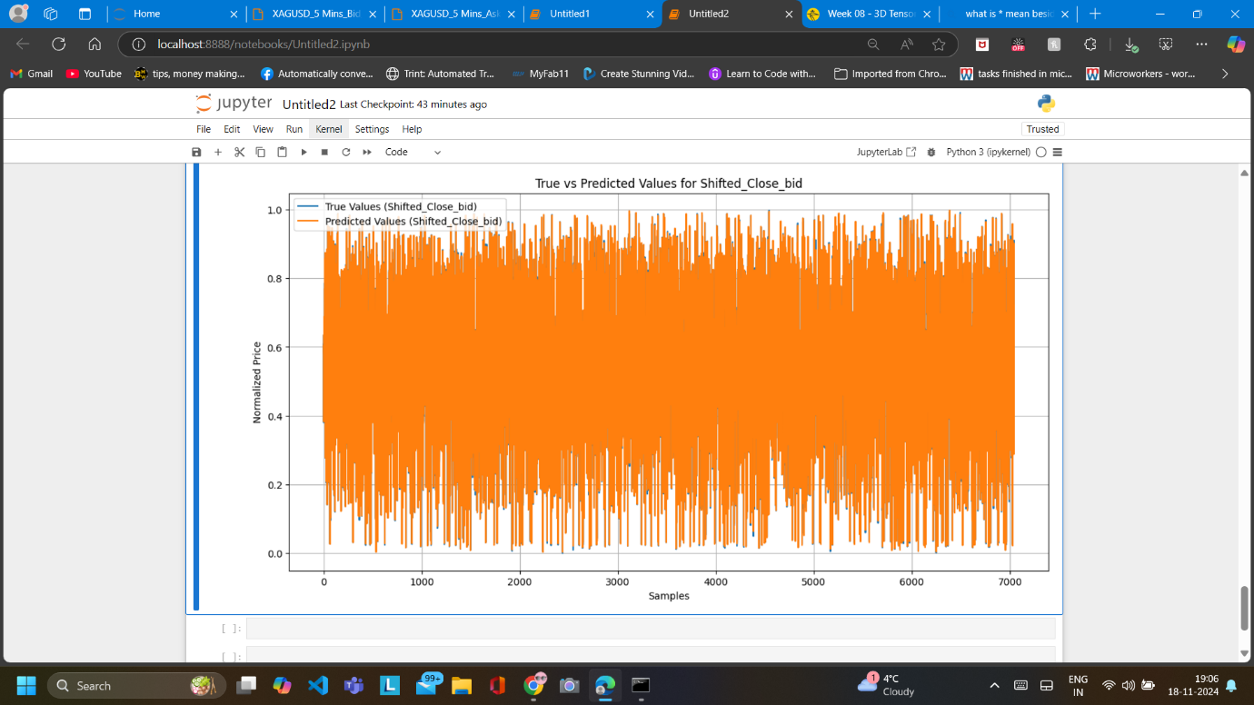

Lab 9 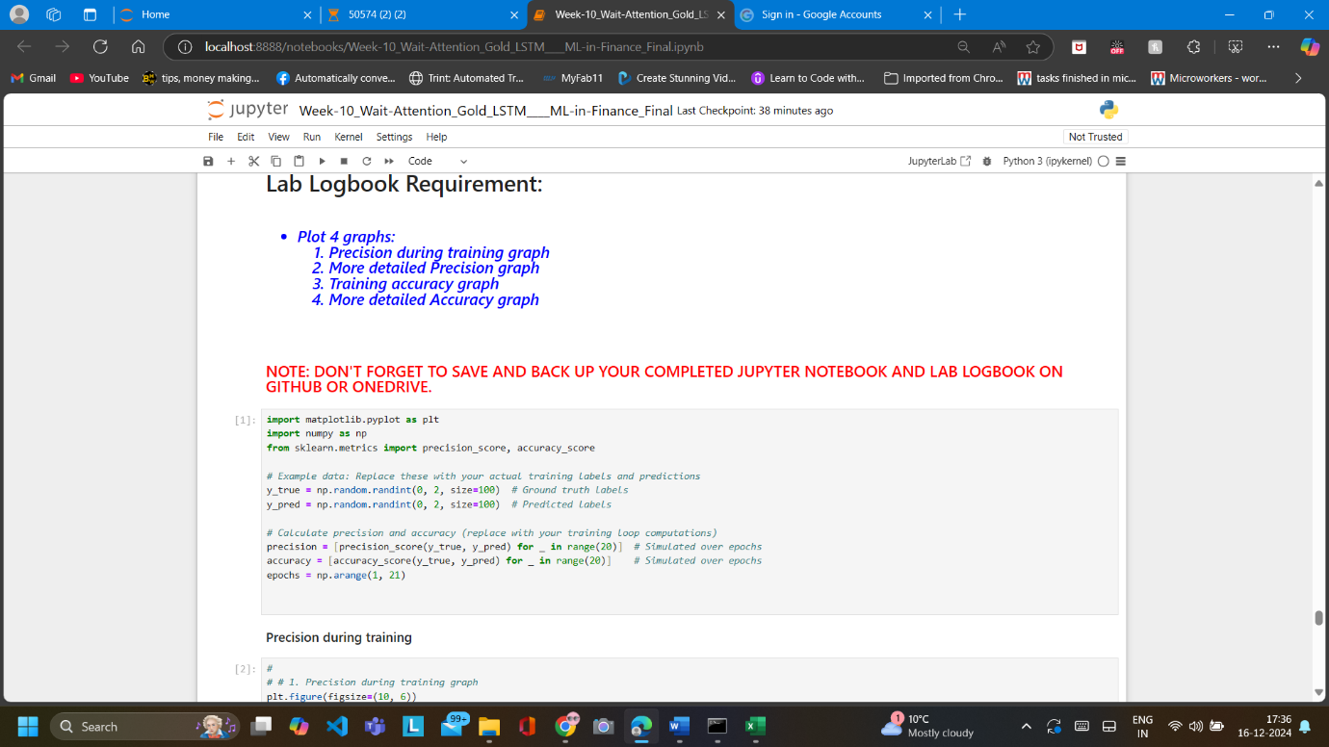

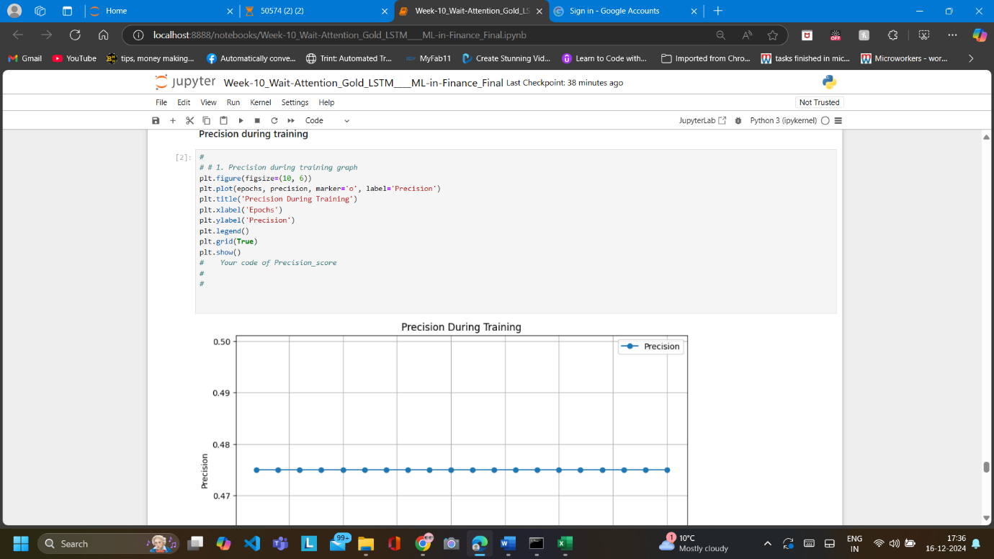

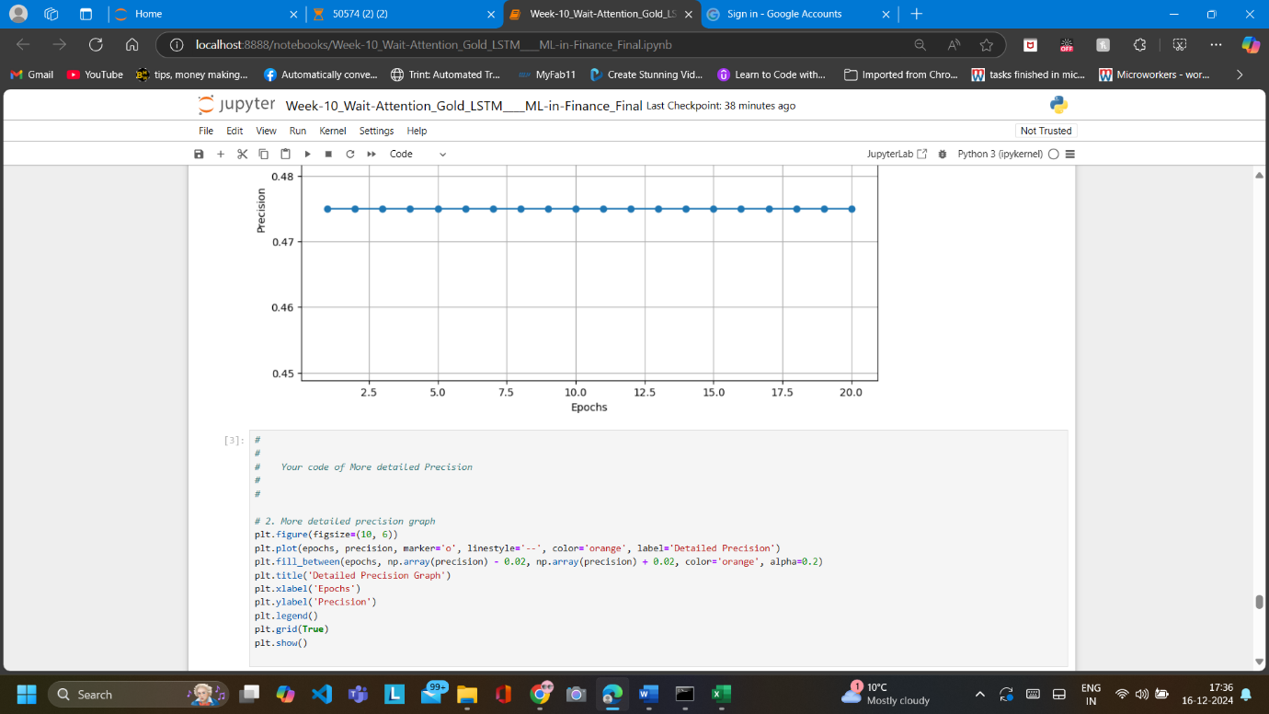

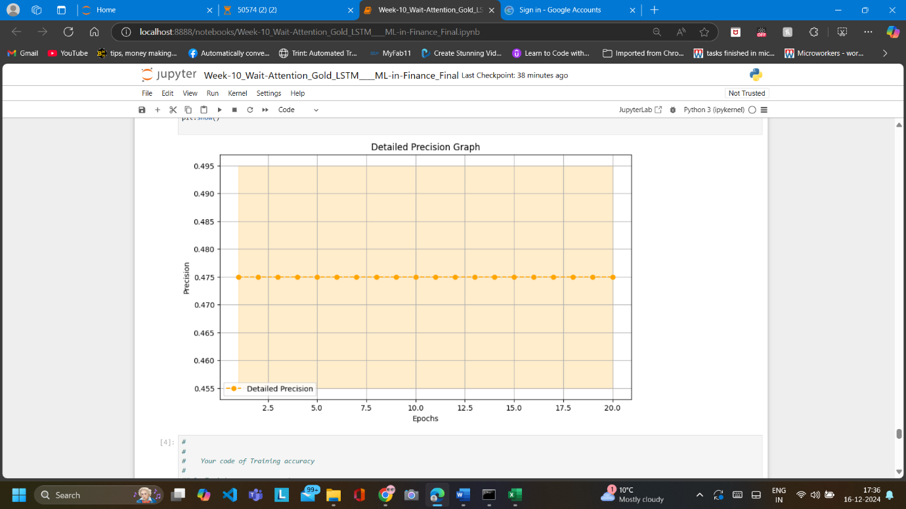

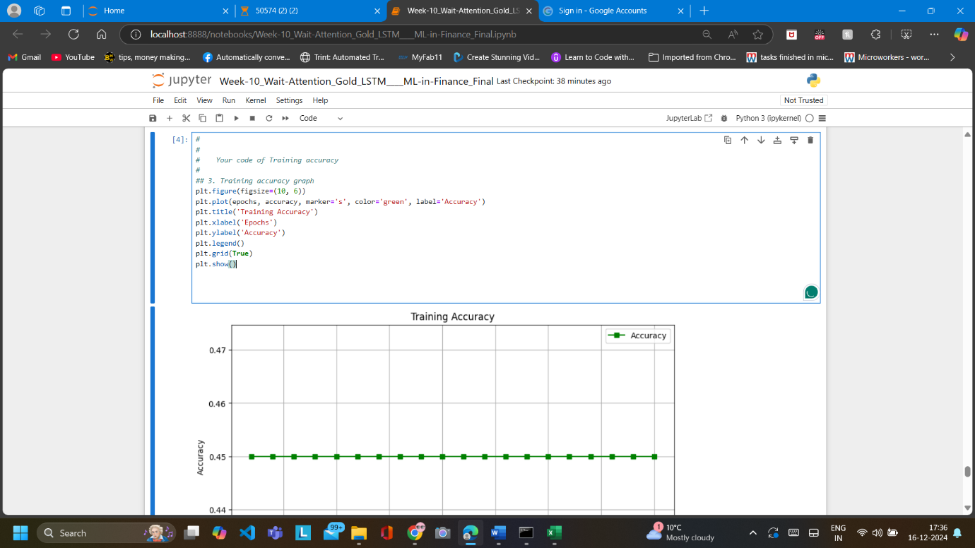

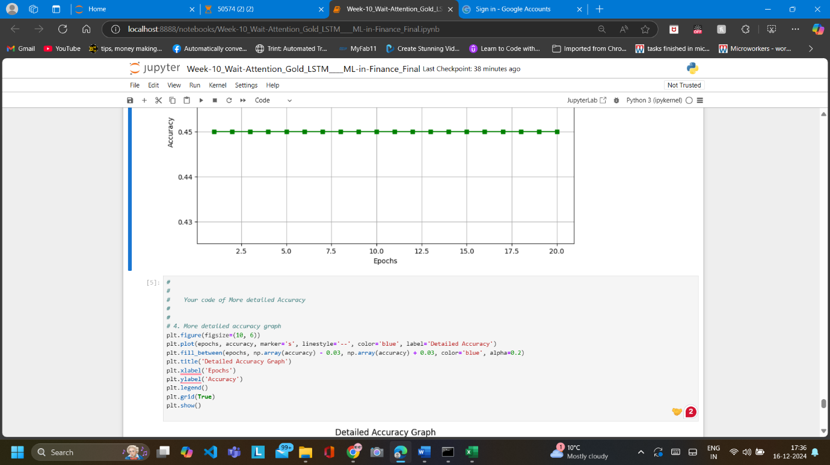

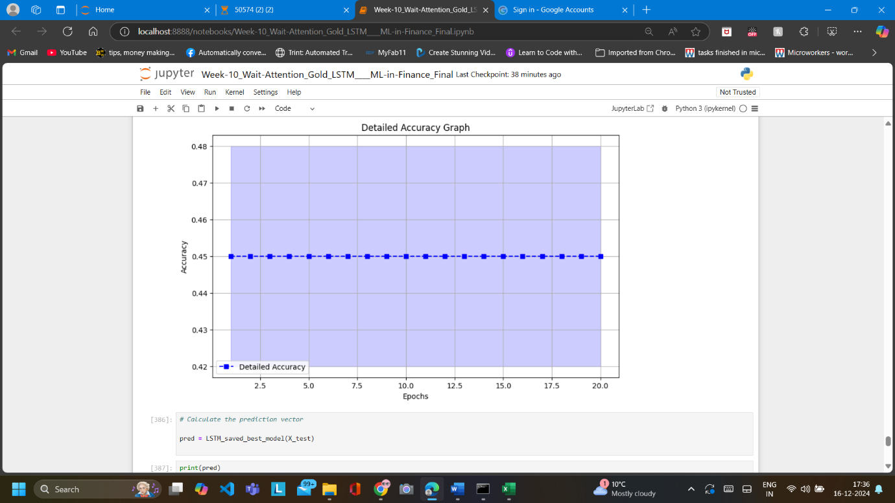

Lab 10

Lab 11

Lab 12

Github URL:

https://github.com/AbhinayGidugu/machineLearning